# InKey Indic-WinScript Keyboard Layout – Oriya

# Vowels

|  |  |  |  |  |  |  |  |  |  |  |  |  |  |
| --- | --- | --- | --- | --- | --- | --- | --- | --- | --- | --- | --- | --- | --- |
| ଅ | ଆ | ଇ | ଈ | ଉ | ଊ | ଋ | ଏ |  | ଐ | ଓ | ଔ | ଅଂ | ଅଃ |
| a | aa/A | i | ii/I | u | uu/U | R | e |  | E | o | O | M | H |
|  | ാ | ി | ീ | ു | ൂ | ൃ | െ |  | ൈ | ൊ | ൌ | ം | ഃ |

# Consonants

|  |  |  |  |  |  |  |  |  |  |  |  |  |  |  |  |  |  |  |  |  |  |  |  |  |  |  |  |  |  |  |  |  |  |  |  |  |  |  |  |  |  |  |  |  |  |  |  |  |  |  |  |  |  |  |  |  |  |  |  |  |  |  |  |  |  |  |  |  |  |  |  |  |  |  |  |  |  |
| --- | --- | --- | --- | --- | --- | --- | --- | --- | --- | --- | --- | --- | --- | --- | --- | --- | --- | --- | --- | --- | --- | --- | --- | --- | --- | --- | --- | --- | --- | --- | --- | --- | --- | --- | --- | --- | --- | --- | --- | --- | --- | --- | --- | --- | --- | --- | --- | --- | --- | --- | --- | --- | --- | --- | --- | --- | --- | --- | --- | --- | --- | --- | --- | --- | --- | --- | --- | --- | --- | --- | --- | --- | --- | --- | --- | --- | --- |
| |  |  |  |  |  | | --- | --- | --- | --- | --- | | କ | ଖ | ଗ | ଘ | ଙ | | k | K | g | G | W | | ଚ | ଛ | ଜ | ଝ | ଞ | | c | C | j | J | w | | ଟ | ଠ | ଡ | ଢ | ଣ | | t | T | d | D | N | | ତ | ଥ | ଦ | ଧ | ନ | | q | Q | ] | } | n | | ପ | ଫ | ବ | ଭ | ମ | | p | P | b | B | m | | |  |  |  |  |  |  |  |  |  |  |  |  |  | | --- | --- | --- | --- | --- | --- | --- | --- | --- | --- | --- | --- | --- | | ୟ | ଯ | ର |  | ଲ | ଳ |  | ୱ | ଵ | ଶ | ଷ | ସ | ହ | | y | Y | r |  | L | L/ll |  | v | V | z | Z | s | h | |

**Conjunct characters:**

A conjunct is typed by pressing x between the consonants. e.g. n x n 🡪 ନ୍ନ

A non-joined conjunct is typed by pressing shift x between the consonants. e.g. n shift x n 🡪 ନ୍‌ନ

*Alternative*: To change to a non-joined conjunct, press the backtick ` key after it.

e.g. ନ୍ନ ` 🡪 ନ୍‌ନ

**Dependent/Independent Vowels:**

The keyboard will normally produce independent vowels, except after consonants, when it will produce independent vowels.

e.g. i 🡪 ଇ g i 🡪 ଗି

To force an independent vowel after a consonant, press a after the consonant.

e.g. g a i 🡪 ଗଇ

*Alternative*: To change one type of vowel to the other, press the backtick ` key after it.

e.g. ଗଇ ` 🡪 ଗି ` 🡪 ଗଇ

Alternate forms:

In addition to altering conjuncts and vowels, the backtick ` key can produce changes like these:

e.g. ୪ ` 🡪 4 toggle digits: script ⬄ roman

**Alternate characters:**

Various related characters can be obtained by pressing the same key again without pausing.

e.g. n 🡪 ନ n 🡪 ଣ n 🡪 ଞ n 🡪 ଙ

If you actually want a sequence of the character, either pause or press a in between.

e.g. n n 🡪 ଣ n a n 🡪 ନନ

**Smart Quotes:**

Press the single quote ' or double quote " key again to switch between left and right smart quotes. e.g. “ " 🡪 ”

**Brackets:**

Press the open or close parenthesis key up to 3 more times to obtain alternative forms of bracketing.

e.g. ( ( 🡪 [ ( 🡪 { ( 🡪 ⌊

**Note to Advanced Users:**

If you need an independent ZWJ or ZWNJ character (very rare), type space followed by x or shift x respectively.

**Oriya WinScript Layout**

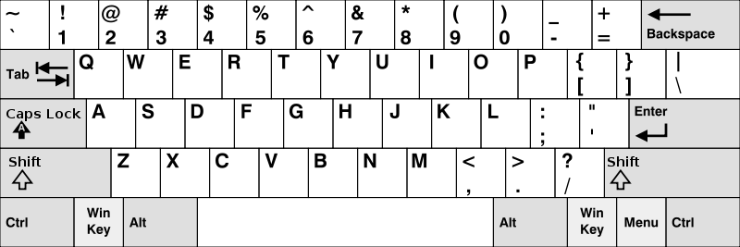

**୦**

**୯**

**୮**

**୭**

**୬**

**୫**

**୪**

**୩**

**୨**

**୧**

**ଯ**

**ଠ**

**ଋ**

**ଐ**

**ଙ**

**ଥ**

**ଊ**

**ଈ**

**ଔ**

**ଌ**

**\**

**ଧ**

**ଦ**

**ଫ**

**ପ**

**ଂ**

**୍**

**ମ**

**ଣ**

**ନ**

**ବ**

**ଭ**

**ୱ**

**ଵ**

**ଛ**

**ଚ**

**ଶ**

**ଷ**

**ଅ**

**ଆ**

**ୟ**

**ଟ**

**ର**

**ଏ**

**ଞ**

**ତ**

**ଉ**

**ଇ**

**ଓ**

**ଳ**

**ଲ**

**ଖ**

**କ**

**ଝ**

**ଜ**

**ଃ**

**ହ**

**ଘ**

**ଗ**

**ସ**

**଼**

**ଢ**

**ଡ**

**ଁ**